

**FASHION SHOP**

**Software Requirement Specification**

– Hanoi, March 21 2023 –

**Record of changeS**

| **Date** | **A* M, D** | **In charge** | **Change Description** |
| --- | --- | --- | --- |
|  |  |  |  |
|  |  |  |  |
|  |  |  |  |
|  |  |  |  |
|  |  |  |  |
|  |  |  |  |
|  |  |  |  |
|  |  |  |  |
|  |  |  |  |
|  |  |  |  |
|  |  |  |  |
|  |  |  |  |
|  |  |  |  |
|  |  |  |  |
|  |  |  |  |
|  |  |  |  |
|  |  |  |  |
|  |  |  |  |
|  |  |  |  |
|  |  |  |  |
|  |  |  |  |

*A - Added M - Modified D - Deleted

**Table of Contents**

I. Overview 3

1. Introduction 3

2. System Functions 4

a. Screen Flow 4

b. Screen Details 4

c. User Authorization 4

d. Non-Screen Functions 6

3. Entity Relationship Diagram 6

4. Use Case Diagram 7

II. Functional Requirements 9

2. Login 9

3. Home page 11

4. Logout 12

5. Profile Management

1. View Profile
2. Manage Order
3. Edit Profile

6. Dashboard 16

7. Products Management 18

8. Cart Management 19

9. Checkout 21

10. Orders Management 22

11. Feedback Products 23

12. Products Catalogue 28

16. Customer

IV. Requirements Appendix

1. Business Rules:

2. Common Requirement: 30

# I. Overview

## 1. Introduction

Fashion shop is a website that allows users to buy books through online shops. Fashion shops help save customers' shopping time, increasing the shopping experience with a variety of fashion genres. Fashion shops are developed with features such as high discount coupon codes, customer information protection, shopping recommendations, etc. Helping customers easily choose and increase authenticity. With quick updates, fashion shops always put the customer's experience first.

*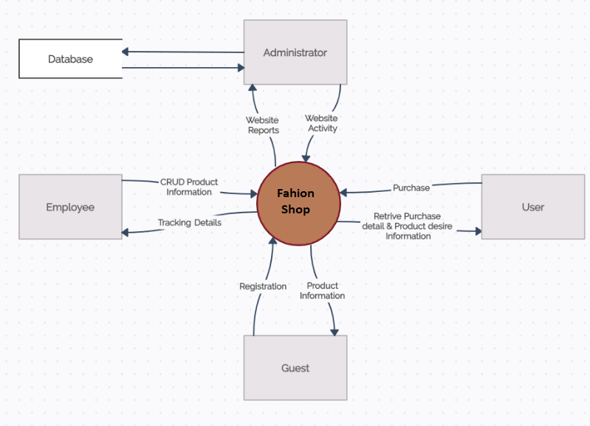fashionshop’s System Context Diagram*

## 2. System Functions

#### a. Screen Flow

#### 

#### b. Screen Details

| **#** | **Feature** | **Screen** | **Description** |
| --- | --- | --- | --- |
| 1 | Common | Homepage | Main functionally page for use |
| 2 | Common | Login | Allow users, Admin, Employees to log in to use systems |
| 3 | Manage customer profile | Customer Profile | Display information users can check. |
| 4 | Manage customer profile | Customer information | Display user's information. |
| 5 | Manage customer profile | Edit Profile | Allow users to change personal information |
| 6 | Manage customer profile | All Order | Display user's order |
| 8 | Manage customer profile | Change Status | Allow employee to change order status |
| 9 | Order products | Cart | Allow users to view cart information |
| 10 | Order products | Create order | Allow users to create orders |
| 11 | Order products | Products Cart | Allows users to view the products currently in the cart and the price of the order |
| 12 | Order products | Billing Address | Allows users to update shipping information and enter discount codes |
| 13 | Common | About Us | Display information about the shop |
| 14 | Common | Contact | Display shop contact information |
| 15 | Common | Product List | Display all products in the store |
| 16 | Common | Product Detail | Display details of a product |
| 17 | Common | View Review | Display a form for users to view and maybe enter product feedback |
| 18 | Common | Related Products | Display suggested related products to customers |
| 20 | Common | Best Selling | Display for customers the best selling products in the store |
| 21 | Common | Search Product | Display customers the related products they are looking for |
| 23 | Site management | Store Management | Display information for employees to manage and view work to be handled |
| 24 | Site management | Update Employee information | Allow employees to change personal information |
| 25 | Site management | Profile employees | Allow employees to update personal information instead |
| 26 | Admin | Dashboard Management | Display the main information related to the store to be managed |
| 27 | Admin | Statistic Revenue | Display the website's sales statistics revenue |
| 28 | Admin | Statistic New Order | Display statistics on the number of new orders |
| 38 | Site management | Product Management | Display list all Product, allow Admin or Employee to manage all product information |
| 39 | Site management | Update Product | Allows Admin and employees to change the information of a product. |
| 40 | Site management | Create Product | Allow Admin and Employee to create a new product. |
| 41 | Site management | Product List | Displays a list of search, filter products that allow Admin or employee to CRUD with the product. |
| 42 | Site management | Order Management | Allows Admin or employees to manage all Order information. |
| 43 | Site management | Order List | Displays a list of search, allows Admin or staff to change the status of the order. |
| 44 | Site management | Order Detail | Display order details. |

#### c. User Authorization

| **Screen** | **Admin** | **Employee** | **Customer** | **Guest** |
| --- | --- | --- | --- | --- |
| Homepage |  |  | X | X |
| Login | X | X | X |  |
| Customer Profile |  |  | X |  |
| Customer information |  |  | X |  |
| Edit Profile |  |  | X |  |
| All Customer’s Order |  |  | X |  |
| Change Status | X | X |  |  |
| Cart |  |  | X | X |
| Create order |  |  | X | X |
| Billing Address |  |  | X | X |
| About Us |  |  | X | X |
| Contact |  |  | X | X |
| Product List | X | X | X | X |
| Product Detail | X | X | X | X |
| View Review | X | X | X | X |
| Related Products | X | X | X | X |
| Best Selling | X | X | X | X |
| Search Product | X | X | X | X |
| Highest rating |  |  | X |  |
| Store Management | X | X |  |  |
| Update Employee information | X | X |  |  |
| Profile employees | X | X |  |  |
| Dashboard Management | X |  |  |  |
| Statistic Revenue | X |  |  |  |
| Statistic New Order | X |  |  |  |
| Product Management | X | X |  |  |
| Update Product | X | X |  |  |
| Create Product | X | X |  |  |
| Product List | X | X |  |  |
| Order Management | X | X |  |  |
| Order List | X | X |  |  |
| Order Detail | X | X |  |  |

In which:

* **Admin**: (Administrator) a person who logged in the website by admin account
* **Employee**: a person who logged in the website by employee account
* **Customer**: A client who logged in the website by a normal account
* **Guest**: Someone access to website but still not login

#### d. Non-Screen Functions

**1 External Interfaces**

**1.1 User Interfaces**

UI-1: The user can log in the system as Admin, Employee or Customer role.

UI-2: The GUI is suitable for display on the computer.

UI-3: The layout of the screen is streamlined, easy to operate, and implemented for the user.

UI-4: Use icons to provide visual insights to users.

UI-5: The text color should be black except for some special texts.

UI-6: Tables appearing on the system must have filter and sort functions.

UI-7: Buttons, links, checkboxes, radio buttons are easy to click to use.

**1.2 Hardware Interfaces**

No hardware interfaces have been identified.

**1.3 Communications Interfaces**

CI-1: The system shall send an email to the user’s email to get new password when user

forgot her/his account password.

CI-2: Users use a mouse to communicate with applications to handle functions that use need.

CI-3: The system shall display a text message to notify about the result of the function that

the user performed.

**2. Quality Attributes**

**2.1 Usability**

• The language is English.

• The Front-end web application should support Chrome browsers.

• The function is divided into menu items for easier access.

**2.2 Availability**

• Book Store shall be available at least 98% of the time between 5:00 A.M and midnight local

time, and at least 90% of the time between midnight and 5:00 A.M local time, excluding

scheduled maintenance servers.

**2.3 Performance**

• All pages have loading speed less than 3 seconds on average

• The system can support up to 500 requests at the same time; The system allows up to

1200 customers register in the system per semester.

• The system shall display confirmation messages to users within an average of 1.5

seconds and a maximum of 3 seconds after the user submits information to the system.

**2.4 Security**

• HTTPs between client and server.

• Token-based authentication using JWT.

• Encrypt password with BCrypt algorithm.

**2.5 Safety**

• The system shall not spread viruses into the devices of users.

• The system shall not include any harm information for users.

• The system shall notify the user to confirm when performing any function that affects the database.

## 3. Entity Relationship Diagram

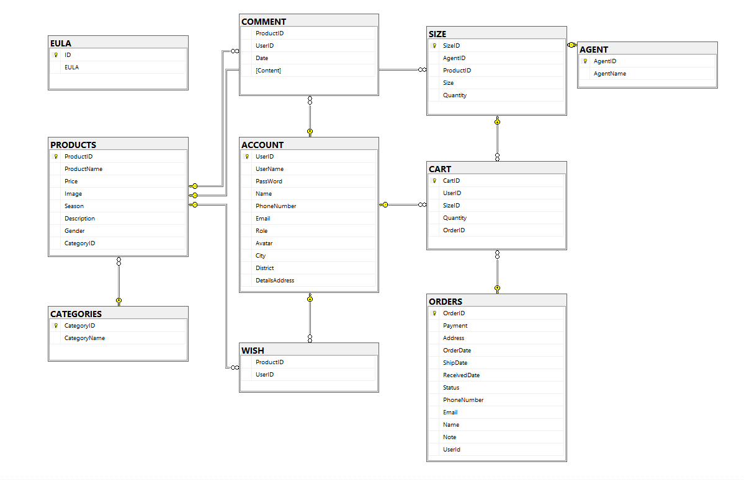

Figure 1: Entity Relation Diagram

**Entities Description**

| **#** | **Entity** | **Description** |
| --- | --- | --- |
| 1 | Product | Main object is clothes |
| 2 | Customer | Consumer, who want to buy clothes |
| 3 | Employee | Manager, saler perform business operation |
| 4 | Account | The registered user of the system |
| 5 | Order | Record information about an order |
| 6 | Order Detail | Record more detail in an order |
| 7 | Category | Classify products by categories |
| 8 | Gender | Classify products by Genres |
| 12 | Cart | Store products which customer want to buy |
| 13 | Payment | payment method of customer |
| 14 | Department | Classify employee into department, admin/saler…etc |

## **4. Use Case Diagram**

## 4.1 Use Case Descriptions

| **ID** | **UseCase** | **Actor** | **Use Case Description** |
| --- | --- | --- | --- |
| 01 | Manage DashBoard | Admin | This function allows Admin to track the revenue of the web, track the level of revenue over the time period that the admin wants to see |
| 02 | Manage Employee | Admin | This function allows Admin to manage employees working in the store |
| 03 | Manage Products | Employee | This function allows Employee to manage the products in the store and keep track of the number of products |
| 04 | Manage Order | Employee | This function allows Employee to manage orders placed in the store, including order date, quantity |
| 06 | Register | Guest | This function allows buyers to register personal information to proceed with ordering and purchasing |
| 07 | Login-logout | Employee,User | This function allows Employee and User to log in and out of the store's system |
| 08 | Manage Profile | User | This function allows User to manage personal information, change personal information |
| 09 | View Old Order | User | This function allows User to manage their orders in the system, add orders and cancel orders in the system |
| 10 | Add Products | Admin | This function allows admin to add products to the system to bring to the store |
| 11 | Edit Products | Admin | This function allows the admin to edit existing products in the system and can edit information about products on the admin interface. |
| 12 | Delete Products | Admin | This function allows admin to delete existing products in the system and can delete products on admin interface |
| 13 | Change Order Status | Admin | This function allows admin, customer to change the status of the order |
| 14 | Filter Order | customer | This function allows admin, customer filter order in the list of orders available in the store system |
| 15 | View Order Detail | Admin,Customer | This function allows the user to view the details of the order |
| 27 | Edit Profile | Customer,Admin | the function allows admin, customer to edit personal information in the interface of edit profile |
| 28 | View Profile | Admin,Customer | The function allows admins and customers to view personal information in the interface of the edit profile |
| 29 | Change Password | Admin,Customer | the function that allows users to change the new password in the store's system |
| 30 | Change Quantity | customer | This function allows the user to change the quantity in the system |
| 31 | View Cart | Customer,Employee | This function allows employees and customers to view the information in the customer's shopping cart |
| 32 | Rating,  Comment | Guest,Customer | This function allows Guest, Customer to rate and comment in the comments and reviews of each product in the store. |
| 33 | View Commnet | Guest,Customer | This function allows Guest,Customer to view comments commented in the product section |
| 34 | Edit Comment | Customer,Guest | This function allows Guest,Customer to edit comments that have been commented previously in the product |
| 35 | Delete Comment | Customer,Guest | This function allows Guest,Customer to delete comments that were previously commented in the product |
| 36 | View Product Detail | Customer,Admin | This function allows users to view information about products in the store system |
| 37 | View DashBoard | Admin | Allows admin to control tasks in the store system |

# II. Functional Requirements

## 1. Login

| ID and Name: | 01 | Actor: | Customer |
| --- | --- | --- | --- |
| Description | This allows users to login into their account(s). Users can also login by Google account, reset password in case they forget and sign up if they don’t have an account. | | |
| Trigger: | Actor clicks the Login button and makes a login. | | |
| Precondition: | None | | |
| Post-conditions: | The system displays their information ( name, picture profile,..) to the homepage. | | |
| Normal flow: | Actor actions | | System response |
| 1. The user(s) go(es) into the homepage and click on the login button. 2. The user(s) input their email and password of their registered account(s) or login by social media accounts.   The use case ends. | | 1. The system pop-up login form to login 2. The system checks for accounts and the user(s) will be redirected to the dashboard, otherwise the user has to correctly input their account(s). |
| Alternative Flows: | 2a. The session is out of date:   1. The systems redirect to login page 2. Use case resumes at main flow step 1   2b. The AccountID invalid: (AccountID of Staff or AccountID inactive):   1. The systems redirect to login page 2. Use case resumes at main flow step 1   2c. The email or password is wrong:   1. Redirect login page with notifying message “Your email or password is wrong. Try again!” 2. Use case resumes at main flow step 1   2d. User forgot password:   1. The system will send an email of a new password to user email 2. Use case resumes at main flow step 1   2e. User sign up:   1. The system will redirect user to register page 2. User sign up new account and verify the email   Use case resumes at main flow step 1[1] | | |
| Exception Flows | N/A | | |
| Business Rules: |  | | |

## 2. Home page

| ID and Name: | 02 | Actor: | Customer |
| --- | --- | --- | --- |
| Description | This allows users to quickly view product’s information in the system such as name, price, author,... and view the website’s services. | | |
| Trigger: | Users access the path homepage or click on the “Home” button on the navigation bar | | |
| Precondition: | None | | |
| Post-conditions: | The system displays homepage and displays product catalog | | |
| Normal flow: | Actor actions | | System response |
| 1. The user login successful or go to URL or click to the Dashboard button   The use case ends | | 2. The system display dashboard page |
| Alternative Flows: | N/A | | |
| Exception Flows | N/A | | |
| Business Rules: | N/A | | |

## 4. Logout

| ID and Name: | Logout Function | Actor: | Logged-in User |
| --- | --- | --- | --- |
| Description | The Logout function allows a logged-in user to end their current session and return to the login screen. | | |
| Trigger: | The user selects the "Logout" option from the application menu. | | |
| Precondition: | The User must be logged into the system | | |
| Post-conditions: | The user's session is terminated , and they are returned to the login screen | | |
| Normal flow: | 1. User selects the “Logout” option from the application menu 2. System prompts the user to confirm their decision to log out. 3. User confirm their decision 4. System logs out the user and ends their session 5. System displays the login screen | | |
| Alternative Flows: | None | | |
| Exception Flows | None | | |
| Business Rules: |  | | |

## 5. Profile Management

a. Customer information

| ID and Name: | 02 – Manage personal profile | Actor: | Customer |
| --- | --- | --- | --- |
| Description:  Trigger: | The system displays the user's information. | | |
| the User wants to see the personal information stored in the system | | |
| Precondition: | PRE_1: Actor has logged into the system. | | |
| Post-conditions: | POST_1: The system displays account information. | | |
| Normal flow: | Actor actions | | System response |
| 1. Click on the avatar icon in the  navigation bar.  3. Click on the “Profile” hyperlink in the menu. | | 2. Display a drop-down menu.  4. Display user information page |
| Alternative Flows: | N/A | | |
| Exception Flows | 4.1 The user is not logged in and the system asks for login | | |
| Business Rules: |  | | |

b. Update profile

| ID and Name: | 03 – Update profile | Actor: | Customer |
| --- | --- | --- | --- |
| Description:  Trigger: | This function allows the actor to update personal profile. | | |
| The user wants to change the information stored in the system | | |
| Precondition: | PRE-1. Actors have been logged into the system.  PRE-2. Actors access personal profile screen | | |
| Post-conditions: | POST-1. The system displays the user's personal information. | | |
| Normal flow: | Actor actions | | System response |
| 1. Select the field which the actor’s information wants to change and update this information.  2. Click on the “Save” button | | 3. Display message: “Successful Update Information” |
| Alternative Flows: | N/A | | |
| Exception Flows | 3.1 The user enters incorrect information and the system returns a message instructing the user to re-enter it | | |
| Business Rules: | 1.Valid date of birth within the allowed input range  2.Phone numbers start with 0 or 84, then 9 more numbers.  3.Name does not enter special characters and is not less than 2 and 4.more than 30 characters  5.ContactTitle can only use the allowed characters, the length is 6.greater than 2 and less than 30 characters  7.Address can only use the allowed characters, the length is greater than 20 and less than 100 characters | | |

c. Manage Customer’s Order

| ID and Name: | 04 – Manage Customer’s Order | Actor: | Customer |
| --- | --- | --- | --- |
| Description: | For users, the system will allow the user to check their order so far. | | |
| Trigger: | The user wants to check the list of orders, products that the user has ordered. | | |
| Precondition: | PRE-1. Actors have been logged into the system.  PRE-2. Actors access personal profile screen | | |
| Post-conditions: | POST-1. The system displays the user's orders information. | | |
| Normal flow: | Actor actions | | System response |
|  | |  |
| Alternative Flows: | N/A | | |
| Exception Flows | If Guests try to access this page without login, the system will sendirect to error 404 page and inform them of the notification. | | |
| Business Rules: | N/A | | |

## 6. Dashboard

1. Filter Revenue

| ID and Name: | 05 – Filter revenue | Actor: | Admin |
| --- | --- | --- | --- |
| Description:  Trigger: | This function allows the actor to view revenue of 12 month or 30 days of a month | | |
| Actor select a date on the calendar to choose “From ”date and “To” date and click on filter button | | |
| Precondition: | PRE_1: Actor has logged in the system with an admin account.  PRE_2: Actor accesses the account management page. | | |
| Post-conditions: | POST_1: The system displays a statistic diagram with data of revenue of 12 month or 30 days of a month | | |
| Normal flow: | Actor actions | | System response |
| 1. Click on the “From” calendar  3. Click on the “To” calendar  4. Click on the “Filter” button | | 2.System pop-up calendar to pick a day/month/year  3.System pop-up calendar to pick a day/month/year  5. The system displays a c statistic diagram with data of revenue of 12 month or 30 days of a month |
| Alternative Flows: | N/A | | |
| Exception Flows | N/A | | |
| Business Rules: |  | | |

## 

## 7. Products Management

1. View products

| ID and Name: | View Product_admin | Actor: | Admin |
| --- | --- | --- | --- |
| Description:  Trigger: | This use case describes the process of viewing product details by the admin. | | |
| The admin wants to view the product details. | | |
| Precondition: | The admin must be logged in to the system. | | |
| Post-conditions: | The admin can view the product details. | | |
| Normal flow: | Actor actions | | System response |
| 1.Click on the "View Product" button.  3.Choose the product to view. | | 2. The system displays the list of products.  4. The system displays the product details. |
| Alternative Flows: | ALT_1:  - No products available  - Actor actions System response  1.Click on the "View Product" button. 2. The system displays a message "No products available."  ALT_2:  - No product selected  - Actor actions System response  1. Click on the "View Product" button.  2. The system displays the list of products.  3.Choose not to select any product. 4. The system displays a message "Please select a product to view." | | |
| Exception Flows | EXC:  - Product does not exist.  - System response: The system displays an error message "Product does not exist." | | |
| Business Rules: | - The admin can only view the product details if they are logged in to the system.  - The admin can only view the product details that exist in the system. | | |

1. Edit Product

| ID and Name: | Edit Product_admin | Actor: | Admin |
| --- | --- | --- | --- |
| Description:  Trigger: | This use case describes the process of editing a product by the admin. | | |
| The admin wants to edit a product. | | |
| Precondition: | The admin must be logged in to the system. | | |
| Post-conditions: | The product details are updated in the system. | | |
| Normal flow: | Actor actions | | System response |
| 1. Click on the "Edit Product" button. 2. Choose the product to edit. 3. Modify the product details. | | 1. The system displays the list of products. 2. The system displays the product details. 3. Click on the "Save" button. 4. The system updates the product details. |
| Alternative Flows: | ALT_1:  - No products available  - Actor actions System response  1. Click on the "Edit Product" button.  2. The system displays a message "No products available."  ALT_2:  - No product selected  - Actor actions System response  1. Click on the "Edit Product" button.  2. The system displays the list of products.  3. Choose not to select any product.  4. The system displays a message "Please select a product to edit." | | |
| Exception Flows | EXC:  - Product does not exist.  - System response: The system displays an error message "Product does not exist." | | |
| Business Rules: | * The admin can only edit a product if they are logged in to the system. * The admin can only edit the product details that exist in the system. | | |

## 

c. Delete Product

| ID and Name: | Delete Product_admin | Actor: | Admin |
| --- | --- | --- | --- |
| Description:  Trigger: | This use case describes the process of deleting a product by the admin. | | |
| The admin wants to delete a product. | | |
| Precondition: | The admin must be logged in to the system. | | |
| Post-conditions: | The product is deleted from the system. | | |
| Normal flow: | Actor actions | | System response |
| 1.Click on the "Delete Product" button. 2.Choose the product to delete.  3.Confirm the deletion of the product. | | 1.The system displays the list of products.  2.The system displays a confirmation message. 3. The system deletes the product from the system. |
| Alternative Flows: | ALT_1: No products available  Actor actions System response  1. Click on the "Delete Product" button. 2. The system displays a message "No products available."  ALT_2: No product selected  Actor actions System response  1. Click on the "Delete Product" button.  2. The system displays the list of products.  3. Choose not to select any product.  4. The system displays a message "Please select a product to delete." | | |
| Exception Flows | EXC_1: Product does not exist.  System response: The system displays an error message "Product does not exist." | | |
| Business Rules: | * The admin can only delete a product if they are logged in to the system. * The admin can only delete the product that exists in the system. | | |

d. Create Product

| ID and Name: | Create Product_admin | Actor: | Admin |
| --- | --- | --- | --- |
| Description:  Trigger: | This use case describes the process of creating a product by the admin. | | |
| The admin wants a product. | | |
| Precondition: | The admin must be logged in to the system. | | |
| Post-conditions: | The product details are created in the system. | | |
| Normal flow: | Actor actions | | System response |
| 1. Click on the "create Product" button. 2. Choose the product to create. 3. Modify the product details. | | 1. The system displays the list of products. 2. The system displays the product details. 3. Click on the "Save" button. 4. The system creates the product details. |
| Alternative Flows: | ALT:  - Product has been created  - Actor actions System response  1. Click on the "edit Product" button.  2. The system displays the list of products.  3. Updates quantity of products | | |
| Exception Flows | * Information of products does not valid * Display messages: Information of products does not valid, re-enter information. | | |
| Business Rules: | * The admin can only create a product if they are logged in to the system. * The admin can only create the product details that not exist in the system. | | |

## 

## 8. Cart management

| ID and Name: | 7. a. Add to Cart | Actor: | Customer / Guest |
| --- | --- | --- | --- |
| Description | This function allows customers to add some fashion into carts which they want to purchase. | | |
| Trigger: | Actor clicks the “Add to cart” button under each item in the homepage or product catalogue . | | |
| Precondition: | PRE_1: Product is in stock and still in business.  PRE_2: Users who have logged into the system or not will still be accepted. | | |
| Post-conditions: | POST_1: The item will be inserted into the cart if these products are still in stock. | | |
| Normal flow: | Actor actions | | System response |
| 1. Users click the “Add to cart” button in the homepage or product catalogue . | | 2. If the product exists in the cart, the cart will update with a quantity increase of 1 pcs.  3. If the product does not exist in the cart, it is just inserted as normal with quantity equal to 1. |
| Alternative Flows: | N/A | | |
| Exception Flows | If the product which the user wants to add to cart is out of stock or stopped in business (updated status recently) , The system will reject add to cart and send a message to customer to select another item. | | |
| Business Rules: | N/A | | |

| ID and Name: | 7.b. View cart | Actor: | Customer, Guest |
| --- | --- | --- | --- |
| Description:  Trigger: | This function allows customers to view any products in their cart before making a payment. | | |
| The customer clicks the cart icon or accesses the path of the cart page. | | |
| Precondition: | None | | |
| Post-conditions: | The system will redirect to the Cart page to view their product information in cart: product name, quantity, price,etc. Moreover, calculate the total amount in order to prepare the checkout. | | |
| Normal flow: | Actor actions | | System response |
| Click on cart icon on the header website | | System will display cart page’s view |
| Alternative Flows: | If user do not add something to cart yet, this page will showing an empty cart notification | | |
| Exception Flows | N/A | | |
| Business Rules: | N/A | | |

| ID and Name: | 7.c. Change quantity | Actor: | Customer, Guest |
| --- | --- | --- | --- |
| Description:  Trigger: | This function allows Customers, Guest to change quantity number of Item in cart | | |
| The customer clicks on [-], [+], [x] button | | |
| Precondition: | User must add product into cart before | | |
| Post-conditions: | The system will change quantity of product in cart or delete product out of cart | | |
| Normal flow: | Actor actions | | System response |
| 1. The user clicks on [-], [+], [x] button | | 1. The system change quantity or delete product 2. The system auto change total of invoice |
| Alternative Flows: | AL1: When users press [+] increase quantity to reach the available quantity, they cannot increase any more.  AL2: When users press [-] decrease the quantity to 11, they cannot decrease any more. | | |
| Exception Flows | If the product has recently deleted or prevented the business from the system, customers can only delete the product. | | |
| Business Rules: | quantity min =1 | | |

## 10. Orders Management

| ID and Name: | UC10-OrderManager_admin | Actor: | Admin |
| --- | --- | --- | --- |
| Description:  Trigger: | This function allows admin to monitor the progress of the order, the status of orders | | |
| The admin accesses the account management page and selects the order management option. | | |
| Precondition: | PRE_1: Actor has logged in the system with an admin account.  PRE_2: Actor accesses the account management page. | | |
| Post-conditions: | POST_1: The system displays a list of order statuses, including completed orders, pending orders, and orders that can be cancelled.  POST_2: If the admin selects the cancel option, the system cancels the selected order and updates the order status accordingly. | | |
| Normal flow: | Actor actions | | System response |
| 1. Admin logs in to the system. System verifies login information and grants access.  3. Admin selects an order to cancel. System prompts the admin to confirm the cancellation. | | 2.Admin navigates to the order System displays a list of order statuses, including completed orders,  management page. pending orders, and orders that can be cancelled.  4. Admin confirms the cancellation. System cancels the order and updates the order status. |
| Alternative Flows: | N/A | | |
| Exception Flows | 1. If the admin is not logged in with an admin account, the system displays an error message and does not allow access to the order management page. 2. If there are no orders to display, the system displays a message indicating that there are no orders to show. 3. If the admin selects an order that cannot be cancelled (e.g., an order that has already been completed), the system displays an error message indicating that the order cannot be cancelled. 4. If the admin cancels an order and there is an error in the cancellation process (e.g., due to a system error), the system displays an error message and the order status remains unchanged. 5. If the admin cancels an order and there is an error in updating the order status (e.g., due to a database error), the system displays an error message and the cancellation is not processed | | |
| Business Rules: |  | | |

## 

| ID and Name: | 10.a Filter Order | Actor: | Admin |
| --- | --- | --- | --- |
| Description:  Trigger: | This function allows admin to filter orders for selected time period | | |
| The admin accesses the account management page and selects the order management option. | | |
| Precondition: | PRE_1: The admin has logged into the system with their admin account.  PRE_2: The admin has navigated to the order management page. | | |
| Post-conditions: | POST_1: The system displays a list of order statuses, including completed orders, pending orders, and orders that can be cancelled.  POST_2: If the admin selects the filter option, the system filters the order list based on the selected time period and updates the list accordingly. | | |
| Normal flow: | Actor actions | | System response |
| 1. Admin logs in to the system. System verifies login information and grants access.  3. Admin selects a "From" date and a System prompts the admin to select a "To" date.  "To" date for the time period. | | 2.Admin navigates to the order System displays a list of order statuses, including completed orders,  management page. pending orders, and orders that can be cancelled.  4. Admin clicks the "Filter" button. System filters the order list based on the selected time period and  updates the list accordingly. |
| Alternative Flows: | N/A | | |
| Exception Flows | 1. If the admin is not logged in with an admin account, the system displays an error message and does not allow access to the order management page. 2. If there are no orders to display, the system displays a message indicating that there are no orders to show. 3. If the admin selects a time period that does not contain any orders, the system displays a message indicating that there are no orders to show for the selected time period. 4. If the admin enters an invalid date (e.g., a date that is in the future), the system displays an error message and does not allow filtering. 5. If there is an error in the filtering process (e.g., due to a system error), the system displays an error message and the order list remains unchanged. | | |
| Business Rules: |  | | |

## 

## 

| ID and Name: | 10.b Change order status | Actor: | Admin |
| --- | --- | --- | --- |
| Description:  Trigger: | This function allows admin to cancel orders in the list | | |
| The admin accesses the account management page and selects the order management option. | | |
| Precondition: | PRE_1: The admin has logged into the system with their admin account.  PRE_2: The admin has navigated to the order management page. | | |
| Post-conditions: | POST_1: The system displays a list of order statuses, including completed orders, pending orders, and orders that can be cancelled.  POST_2: If the admin selects the cancel option for an order, the system displays a confirmation message asking if the admin wants to cancel the order.  POST_3: If the admin confirms the cancellation, the system removes the order from the order list. | | |
| Normal flow: | Actor actions | | System response |
| 1. Admin logs in to the system. System verifies login information and grants access.  3. Admin selects an order to cancel. System displays a confirmation message asking if the admin wants to cancel the order. | | 2.Admin navigates to the order System displays a list of order statuses, including completed orders,  management page. pending orders, and orders that can be cancelled.  4. Admin clicks "OK" to confirm System removes the order from the order list and displays a message confirming |
| Alternative Flows: | N/A | | |
| Exception Flows | 1. If the admin is not logged in with an admin account, the system displays an error message and does not allow access to the order management page. 2. If there are no orders to display, the system displays a message indicating that there are no orders to show. 3. If the admin cancels the order cancellation process, the system displays a message indicating that the order was not cancelled. 4. If there is an error in the cancellation process (e.g., due to a system error), the system displays an error message and the order remains in the order list. | | |
| Business Rules: |  | | |

## 12. Feedback

| ID and Name: | UC10 - Feedback | Actor: | Customer |
| --- | --- | --- | --- |
| Description | This function allows customer to give their feeling about the products which they have bought | | |
| Trigger: | Actor clicks the “Review” button after they confirm to change order status to state “Delivered” and makes a login. | | |
| Precondition: | PRE_1: Customer has logged in the system with an admin account.  PRE_2: Customer accesses the account management page.  PRE_3: Customer having ordered and confirmed the completion of the order | | |
| Post-conditions: | POST_1: A new feedback stored in to the system and announce to the customer notification | | |
| Normal flow: | Actor actions | | System response |
| 2. Customers filled in the form with their comment, rating, upload image file and press review button. | | 1.The system displays feedback form allowing customers to fill in the blank ( comment, rating, profile,..) to the homepage.  3. The system processes these data and checks validation. If there are no error occurs, your data will store into the database and display successful message |
| Alternative Flows: | If customer do not fill in the blank and press review, a new review still created with rating equals to 1 star and their comment and image will be null | | |
| Exception Flows | If the customer upload a file incorrect (not be JPG, JEPG, PNG), the system not allows this file and require customer upload again | | |
| Business Rules: | file upload is only Image format such as JPG, JEPG, PNG | | |

**12. Products Catalogue**

| ID and Name: | UC11 - Filter | Actor: | Customer |
| --- | --- | --- | --- |
| Description | Allow users to search products according to their preferences, use the criteria of product classification to filter the product list which they want to buy | | |
| Trigger: | User clicks the to the book’s properties such as category, supplier to find the fashion they want | | |
| Precondition: | PRE_1: Customer accesses to the products catalogue.  PRE_2: Product list not be empty | | |
| Post-conditions: | POST_1: A new product list that fit to the customer’s need display | | |
| Normal flow: | Actor actions | | System response |
| 1. User click to book’s properties such as category, supplier, range of price   4. If a customer finds a product that they wanted, they can click the add to cart button and checkout if they want. | | 2. The system use filter of the customer to select a new list that fit to the customer’s need  3. If customers click more button on sort by button, the system will sort the list product according to increase price, decrease price, new product, etc. |
| Alternative Flows: |  | | |
| Exception Flows |  | | |
| Business Rules: |  | | |